# CS 255 System Design Document Template

This template lays out all the different sections that you need to complete for Project Two. Each section has guidance to prompt your thinking. You will need to continually reference the interview transcript as you work to make sure that you are addressing your client’s needs. There is no required length for the final document. Instead the goal is to complete each section based on what your client’s needs are. Remove this note when you are finished, and replace all bracketed text with the relevant information.

## UML Diagrams

### UML Use Case Diagram

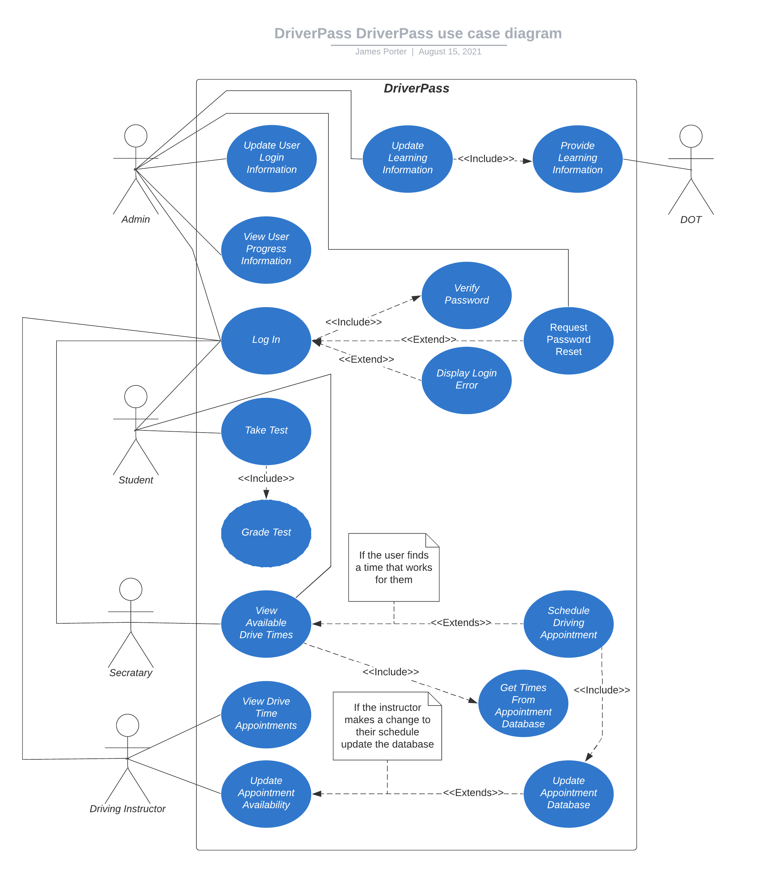

### UML Activity Diagrams

### UML Sequence Diagram

### UML Class Diagram

## Technical Requirements

Technical requirements can be broken down into three different categories, hardware, software, and geographic information.

For this system, the following are some hardware requirements:

* Server for the system
* Computer setup for the secretary
* Computer setup for the admin

For this system, the following are some software requirements:

* Windows operating system, most up to date
* Software to run the various user interfaces
* Security software for all computers used by DriverPass
* Able to be web based to update as necessary

For this system, the following are some geographic information requirements:

* Server and company computers will be placed within an office space
* Server will need separate locked door only to be accessed by administrator